AgAlert
Dupont to Recall Imprelis Herbicide
Cecil Tharp, Pesticide Education Specialist
Melissa Medley, Weeds and IPM Specialist
Jane Mangold, Rangeland Weeds Specialist
Fabian Menalled, Crop Weeds Specialist

Due to 355 complaints regarding tree death and injury associated with the use of the herbicide Imprelis, DuPont has immediately suspended sale and announced plans to issue a total recall of this product. Imprelis (aminocyclopyrachlor) is currently labeled for use on broadleaf weeds in turf. According to an article in the New York Times, trees with shallow root systems like willows, poplars, and conifers appear to be especially susceptible to this herbicide (http://www.nytimes.com/2011/07/15/science/earth/15herbicide.html?pagewanted=all). Injury symptoms can include yellowing and browning of needles, needle loss, and twisting or distortion of new growth (http://extension.psu.edu/greenindustry/giec/news/2011/some-observations-on-imprelis-injury-to-trees). Below are photographs showing suspected Imprelis injury in spruce and fir.

Distributors of Imprelis herbicide should read the Letter to Turf Management Product Distibutors (http://www.imprelis-facts.com/letters-statements/letter-to-turf-management-product-distributors/) for specific directions from Dupont regarding the recall of this pesticide.

This letter describes action by Dupont to initiate recall and refund of this product by mid-August. Distributors should be contacted by Dupont regarding this recall. If distributors have any questions regarding this process contact the Dupont Customer Service Center at 1-800-342-5247.

This letter also includes instructions on how to collect this product from customers / applicators. Applicators should be prepared to return this pesticide product in upcoming weeks.

Additional information regarding the Imprelis recall can be found at http://www.enewspf.com/latest-news/science-a-environmental/25932-dupont-to-issue-recall-of-pesticide-linked-to-tree-deaths.html, For diagnosing if ‘Imprelis’ herbicide has damaged your trees contact your local MSU Extension Agent or the MSU Pesticide Education Program (406)994-5067. For conducting a legal investigation or seeking enforcement action contact the Montana Department of Agriculture (406)444-5400.

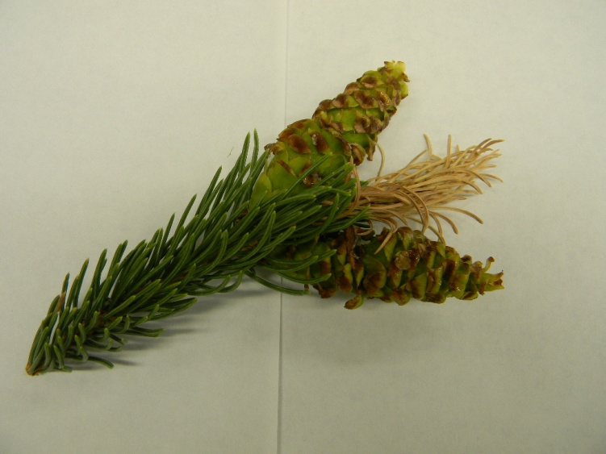
Figure 1. Browning of needles and cone in spruce (Photo courtesy of Melissa Medley, Montana State University, 2011).
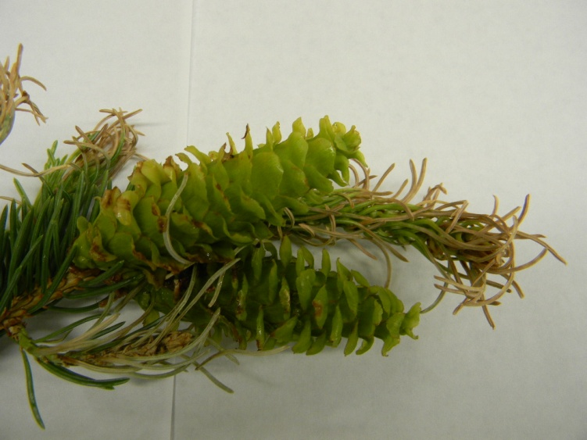
Figure 2. Needle and cone distortion in spruce (Photo courtesy of Melissa Medley, Montana State University, 2011).

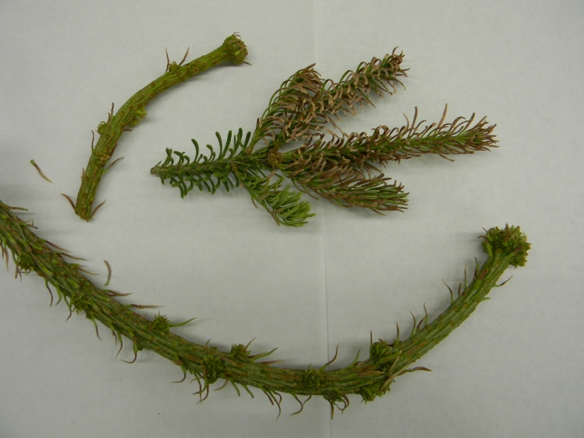
Figure 3. Needle browning and new growth distortion in subalpine fir (Photo courtesy of Melissa Medley, Montana State University, 2011).

